IOT SOLUTION FOR SMART CITY
Smart Street Light using NI myRIO-1900
Ahmed Sadriwala, Dr. Mohab Abdelhameed Abdellatif Mangoud
Abstract.
With the increasing population, it is getting difficult to manage the cities by the government. Hence the idea of smart cities is popular and accepted. Many countries are implementing this concept of smart cities partially or completely in many parts. This paper presents an IoT solution for smart cities focusing mainly on streetlights and traffic lights. The solution is based on 2 main components: myRIO (IoT hardware) and Thingspeak (IoT cloud platform). The myRIO communicates with Thingspeak using REST (Representational State Transfer) API through HTTP protocol. The method of communication is standard Wi-Fi. The solution controls and communicates the actuators and sensors respectively using the myRIO. The myRIO pushes all the essential data to the IoT Platform through Wi-Fi. The IoT architecture is an edge architecture where the myRIO does some computation and processing like a PID controller for controlling the light intensity and image processing to detect objects. The solution also monitors any traffic violation like when a car has crossed the traffic line when the traffic light is red. It also monitors weather conditions like temperature, Wind direction, and wind speed. As we know there are cases when there is no mobile network available in remote locations, so this IoT device connected to the streetlight has an emergency button to notify the cloud that emergency service is needed at the location of the streetlight. [6] [5]

Introduction[6] [5]
Smart Cities seem to become a reality as many countries are moving ahead to start converting their current cities to smart cities. With increasing population, its becoming difficult to manage and control the city due to a lack of real-time data and decision-making. IoT (Internet of things) would be a perfect solution for it. IoT is a collective network of connected devices and technology that facilitates communication between devices and the cloud, as well as between the devices themselves to provide real time data. However, changing the infrastructure completely to implement IoT may not be a good solution in terms of the finances. IoT solutions should be able to work with the current infrastructure than making the government change the whole working infrastructure. This document talks about how this IoT Solution for streetlights and traffic lights can easily sit on existing infrastructure or be part of a whole new infrastructure to make a city smart. The solution monitor and controls streetlight and traffic light by itself and send data periodically to an IoT Platform to view it in real time and do analytics later. It also monitors the weather of the area and does extra functionality like capturing traffic violations, measuring the sound intensity, and notifying emergency services about emergencies. Several of these functionalities occur instantaneously hence edge IoT architecture will be best fit for this solution. MyRIO is a capable IoT device which can do edge processing. [6] [5]

1.1 Functionality
The IoT solution can do several functions. As mentioned before due to the edge IoT architecture, the IoT device also runs complex functions before the data is sent to the IoT platform. Below is the list of all the functions and capabilities of the IoT Device.
- The IoT device can control the traffic light.
- It also monitors weather parameters like:
  - Wind direction (degrees)
  - Wind speed (knots)
  - Light intensity
  - Ambient temperature (‘C)
- It controls the light of the LED using a PID controller. The PID controller gives light only when the ambient light is not enough to light up the roads.
- Measure the sound level of the surroundings and notify the IoT Platform when the sound is over a certain decibel.
- The camera also takes live video of the road and counts the number of cars using video processing running in real-time in the IoT device. [1]
- It notifies the IoT platform when a traffic violation occurs due to the car crossing the traffic light while the traffic signal is red.
- Finally, an emergency button is connected. Whenever the button is pressed it instantly notifies the IoT platform that an emergency service is required.
- The device sends a health pulse every 15 seconds to notify the IoT platform the device is active and all the data is sent every 60 seconds to the IoT platform.

Proposed System and Design
Raw data from the sensor or to actuators are connected to myRIO. Then the data is processed and analyzed in it. Later the useful data is pushed to the IoT platform through Wi-Fi and any application can pull data from IoT platform. Below are the proposed data flow of the solution:
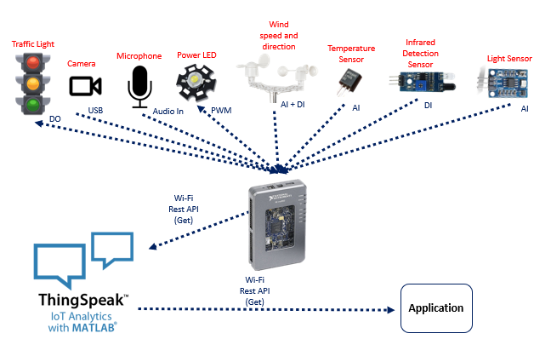

Technical Details
In this session, the technical aspect of the devices and software used are explained.

3.1 Sensor and actuators
This project has several sensors and actuators. And below is the list of them:
S.No. | Item | Sensor / Actuator
1 | 3 LED (Red, Yellow, Green) | Actuator
2 | Camera | Sensor
3 | Microphone | Sensor
4 | Power LED | Actuator
5 | Anemometer | Sensor
6 | Wind Vane | Sensor
7 | Temperature senor | Sensor
8 | Infra-red detection sensor | Sensor
9 | Light Sensor | Sensor
10 | Button | Sensor

The 3 LEDs are being used to simulate traffic lights and the IoT device controls and monitors them.
The camera is used to detect objects when the light turns red to count the number of cars. [1]
A microphone is also connected to the IoT device to monitor the noise amplitude and later notify the IoT platform when the noise level goes above a certain decibel.
A power LED is also used to simulate a streetlight and the IoT device controls it using PWM (Pulse width modulation). [6]
Anemometer is also connected to the IoT device to measure wind speed. Each spin of the sensor gives 2 pulses. Measuring the number of pulses every second can be used to measure wind speed in knots.
Also, a wind vane is connected. Each direction has a certain resistance which could be measured in terms of voltage when using a voltage divider.
To measure the ambient temperature, LM35 is used. The sensor could be directly connected to the IoT device.
An infrared detection sensor is placed near the traffic light to detect the car crossing when the light turns red. The sensor is connected directly to the IoT device.
A light sensor is used to control the streetlight and its intensity depending on the ambient light. The light sensor is a simple LDR (Light Dependent Resistor) that is connected to the analog input of the myRIO.
Finally, a button is used as an emergency button. It is also connected directly to the IoT device.

3.2 myRIO[1]
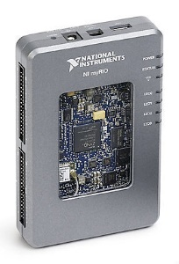
The main IoT device used is myRIO (1900) from NI (National Instruments). This device has several capabilities compared to generic small IoT devices. It has a microcontroller and FPGA for data processing and video processing. Besides this, it has an inbuilt Wi-Fi module (IEEE 802.11 b,g,n) which makes it an ideal IoT device for this solution. It also has several GPIOs as mentioned below:
- Analog input (AI) x 6
- Analog output (AO) x 6
- Digital input & output (DIO) x 40
- 3.5 mm Jack Audio In x 1
- 3.5 mm Jack Audio Out x 1
- USB 2.0 x 1
With all these capabilities it makes myRIO an ideal device for edge IoT architecture. Some of the sensors and actuators need to have a conditioning circuit before connecting to the GPIO of myRIO. The device once connected to Wi-Fi it is capable to communicate to the IoT platform directly.

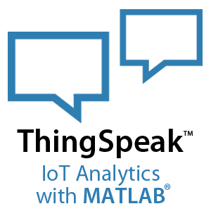
3.3 Thingspeak IoT Platform[2] [3]
In this solution, we are using Thingspeak as the IoT platform. Thingspeak is from the company that made MATLAB i.e. MathWorks. This IoT platform is very easy to use with any IoT device. This platform has a very seamless method of communication with MATLAB which make it an ideal platform for data analytics and processing. The IoT platform has three main methods to send data: REST API, MQTT API, and MATLAB function. MATLAB function is only possible with MATLAB software, hence only 2 options are available for myRIO i.e., REST API & MQTT API. We chose to use REST API for this solution because Rest API gives you the capability to create, read, write and delete channels/fields unlike MQTT can only read and write data. [3]

3.4 LabVIEW[1]
As we are using myRIO as the IoT device the only way to program it is using LabVIEW. LabVIEW is also from the makers of myRIO which is NI (National Instrument). It is a graphical language to program both the real-time and the FPGA chip in myRIO.

Implementation

4.1 Hardware Setup
To collect data from sensor or to control actuator, myRIO cannot be connected directly to them therefore they may need conditioning circuit. Some sensors will be connected directly to myRIO. Below are details of the sensors and its connection to myRIO:
- Light sensor – It goes through condition circuit to convert the resistance to voltage which is connected to analogue pin.
- Temperature sensor – LM35 was connected directly to analogue pin. [5]
- Anemometer – It produces pulses hence directly connected to digital In
- Wind Vane – It produces different resistance at different direction. To convert it voltage we used voltage divider.
- Infra-red object detection sensor – The signal goes to a conditional circuit which produces a pulse every time an object is in front of the sensor.
- Microphone – It is connected directly to the 3.5 mm Audio jack input.
- Camera – Connected directly using USB. [1]
- Emergency button – Connected directly to a digital In pin of myRIO. [1] [5]
Below are details of the actuator and its connection to myRIO:
- Power LED – It is connected to PWM pin of myRIO which can control the intensity of light.
- Traffic Light – It consist of 3 LEDs which are connected directly to Digital out pin of myRIO
Below is the image of how the whole hardware system looks once assembled:
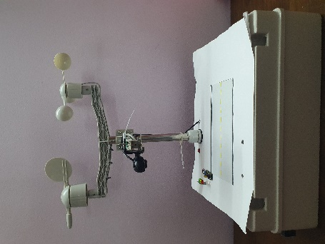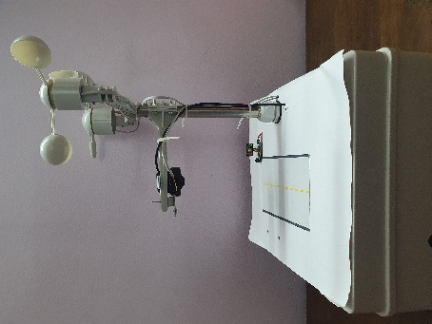
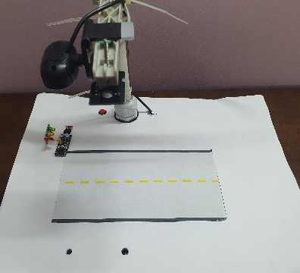

4.2 LabVIEW Programming[6]
LabVIEW program is split into main two:
- Real Time programming
- FPGA programming
Coding for both real-time and FPGA is different in LabVIEW. FPGA is mainly used for acquiring data and does only a rudimentary data process. However, the real-time process gets the data from the FPGA and can do more advance processes like PID controlling and video processing.
Below are the functions, coded in the real-time processor using LabVIEW:
- PID controller to control the light intensity using PWM. It uses the light sensor data as it processes data and the setpoint is fixed. [6]
- Compare the sound amplitude to a certain value to give an alert if it is higher than it.
- Capture and do a video process to detect objects on road.[1]
- Control traffic light by keeping red, yellow, and green light on at specific timing intervals.
- Monitor all weather parameters and emergency button.
- Constantly looks for a traffic violation when the traffic light glows red.
- Sending Data every 60 seconds using the HTTP protocol to the IoT Platform
- Sending a heartbeat date every 15 seconds using the HTTP protocol to the IoT Platform
Below is the front panel of the real-time program.
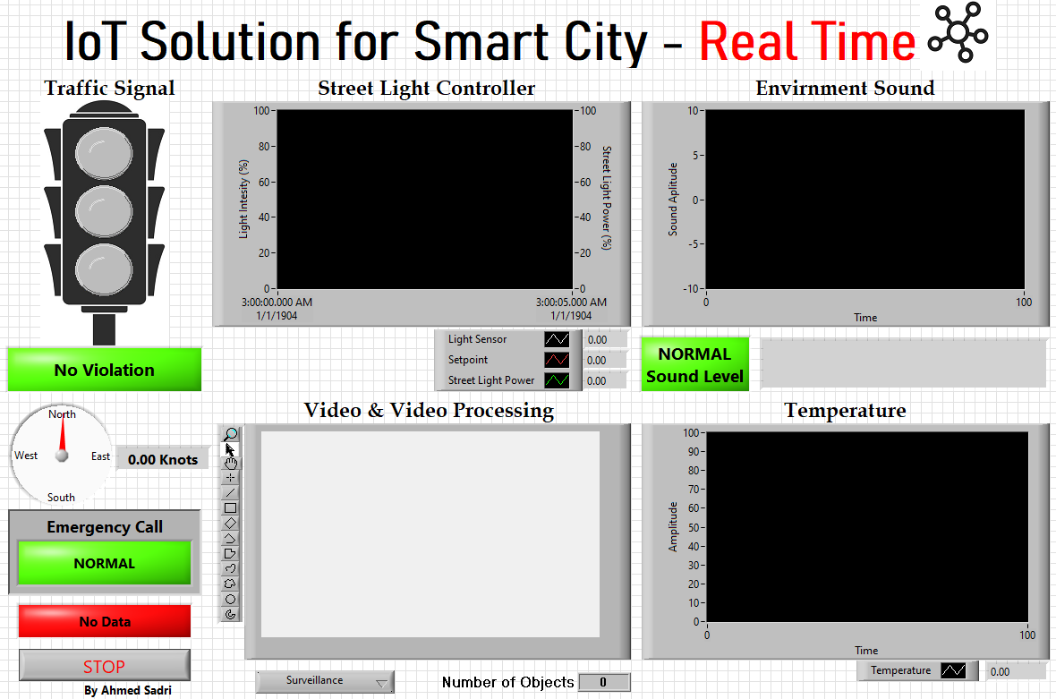
In FPGA program, several loops are running in parallel only to acquire data and average the data out before sending it to the real-time processor. Below is the front panel of the FPGA program.
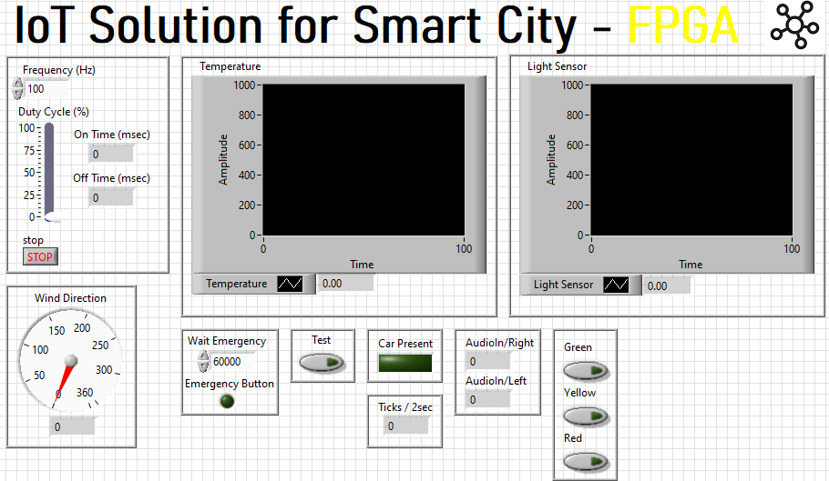

4.3 Thingspeak IoT Platform Setup
Before we send data to the IoT platform we need to create a channel on Thingspeak (Channel ID 1987897). In the channel, 8 fields were created as mentioned in the order below.
- Temperature – For recording ambient temperature in Celsius.
- Device Health – Stay green when it received heartbeat data from the IoT device.
- Wind Speed – For recording Wind Speed in knots.
- Wind Direction – For recording wind direction in degrees.
- Light Intensity - For recording Light intensity in %.
- Traffic Light – Turns red and green depending on the traffic light status.
- Object Detection – Give a numerical value to show the current object on the road.
- Emergency Button – Glows red when the person presses the emergency button.
Once a channel is made, unique write and read API keys are created by Thingspeak. Every time we need to read or write data these API keys will be needed. As mentioned before the solution uses REST API through HTTP protocol to receive message form myRIO. We use the GET method to post data. Below is the image of how the data look on the IoT platform:
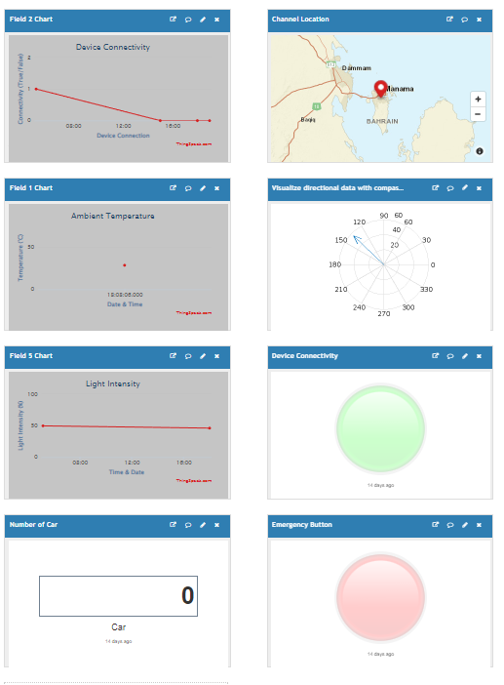

Conclusion
In conclusion, the data flows from sensors to myRIO to Thingspeak successful using Rest API protocol which is provided by Thingspeak. MyRIO also make decision like the intensity of light and video processing to detect object. This solution could be added on current infrastructure as well. The paper also proofs Thingspeak is a useful platform for viewing data as well as for analysis later. We also found that myRIO is a good IoT device which is capable of edge computing.

Reference
[1] National Instruments, & Doering, Mr. (2015). NI myRIO Vision Essentials Guide. National Technology and Science Press.
[2] Nettikadan, Mr., & Raj M.S., Mr. (2018). International Journal of Applied Engineering Research. Smart Community Monitoring System Using Thingspeak IoT Platform, 13(0973–4562), 7.
[3] Learn More - ThingSpeak IoT. (n.d.). https://thingspeak.com/pages/learn_more
[4] Jerome, Mr., Ahmed Saied, Mr., Bekal, Ms., S. M., Mr., & V.A., Mr. (2017). International Journal of Internet of Things. ‘AutoHome’ an NI MyRIO Based Project. https://doi.org/10.5923/j.ijit.20170602.04
[5] Swain, Mr., Cherukuri, Mr., Kumar Mishra, Mr., Appasani, Mr., Patnaik, Mr., & Bizon, Mr. (2021). Electronics. LI-Care: A LabVIEW and IoT Based EHealth Monitoring System, 16.
[6] Prabu, Mr., V, Mr., S, Mr., Kumar S, Mr., & R, Mr. (2020). International Journal of Innovative Research in Electrical, Electronics, Instrumentation and Control Engineering. IoT Based Temperature Monitoring and Controlling System by Using MyRIO-LabVIEW, 8, 4. https://doi.org/10.17148/IJIREEICE.2020.8405

